**SEMANTICS OF DATA MINING SERVICES IN CLOUD COMPUTING**

**Abstract:**

Data mining, the process of discovering patterns and knowledge from large volumes of data, has become increasingly important in various domains, including business, healthcare, and finance. With the advent of cloud computing, which provides scalable and on-demand access to computational resources, the landscape of data mining has been significantly transformed. This abstract explores the semantics of data mining services within the context of cloud computing, highlighting how cloud-based platforms enhance data mining capabilities and address traditional challenges.

Cloud computing offers a versatile environment for data mining by providing scalable storage, powerful computational resources, and flexible access to data. By leveraging cloud services, organizations can process vast datasets more efficiently and perform complex data mining tasks without the limitations of on-premises infrastructure. Cloud-based data mining services facilitate the deployment of advanced algorithms, machine learning models, and analytics tools that are crucial for extracting actionable insights from data.

One of the key advantages of cloud-based data mining is the ability to scale resources dynamically based on demand. This elasticity allows organizations to handle large-scale data mining tasks with ease, reducing the time and cost associated with managing physical hardware. Additionally, cloud platforms support a variety of data mining techniques, including classification, clustering, association rule mining, and anomaly detection, through integrated services and frameworks.

The semantics of data mining services in cloud computing also encompass the effective management and utilization of metadata, data integration, and data quality. Cloud environments provide mechanisms for metadata management, which helps in organizing, categorizing, and accessing data efficiently. Furthermore, cloud-based platforms often offer tools for integrating data from heterogeneous sources, ensuring consistency and improving the quality of the data used for mining.

Despite these benefits, challenges such as data privacy, security, and compliance must be addressed. Ensuring the confidentiality and integrity of data in a cloud environment is crucial, as data mining often involves sensitive information. Cloud providers and users must implement robust security measures and adhere to regulatory requirements to mitigate risks.

In conclusion, the integration of data mining services with cloud computing offers significant advantages in terms of scalability, flexibility, and efficiency. By understanding the semantics of these services, organizations can better leverage cloud-based data mining to gain valuable insights and drive decision-making processes while addressing associated challenges and ensuring data security.

**Introduction: Semantics of Data Mining Services in Cloud Computing**

The exponential growth of data generated by various sources—ranging from social media and IoT devices to enterprise systems—has heightened the need for advanced data mining techniques to extract valuable insights. Data mining, which involves analyzing large datasets to identify patterns, correlations, and trends, is critical for informed decision-making across multiple domains, including finance, healthcare, marketing, and beyond. Traditionally, data mining tasks required substantial computational resources and storage, often posing significant challenges in terms of scalability, cost, and efficiency.

The advent of cloud computing has revolutionized how organizations approach data management and analytics. Cloud computing provides on-demand access to a pool of scalable resources and services over the internet, enabling organizations to leverage powerful computing capabilities without the constraints of on-premises infrastructure. This paradigm shift has significant implications for data mining, offering new opportunities and challenges that reshape traditional approaches to data analysis.

Cloud computing platforms offer several advantages for data mining services, including elasticity, cost-effectiveness, and accessibility. By leveraging cloud infrastructure, organizations can dynamically scale their computational resources to handle large-scale data mining tasks, reducing the need for upfront capital investment in hardware and software. Additionally, cloud platforms facilitate access to a wide array of data mining tools and services, including machine learning frameworks, big data analytics, and advanced algorithms, which can be deployed and managed more efficiently in a cloud environment.

The semantics of data mining services in cloud computing involve understanding how these services are structured, managed, and utilized within a cloud ecosystem. This includes the integration of data mining tools with cloud infrastructure, the management of metadata, and the handling of data quality and privacy concerns. Cloud-based data mining services must address these aspects to ensure effective data analysis and to leverage the full potential of cloud computing.

Moreover, the cloud environment introduces new challenges related to data security and privacy. As organizations increasingly rely on cloud-based data mining, ensuring the confidentiality, integrity, and compliance of data becomes paramount. Effective strategies must be implemented to safeguard sensitive information and adhere to regulatory standards.

This introduction explores the intersection of data mining and cloud computing, highlighting how cloud platforms enhance data mining capabilities while presenting new considerations for managing data and ensuring security. By understanding these dynamics, organizations can better harness the power of cloud-based data mining to drive insights and decision-making processes.

**Literature Survey: Semantics of Data Mining Services in Cloud Computing**

The integration of data mining services with cloud computing has garnered significant attention in recent years. This literature survey reviews key contributions in the field, highlighting how cloud computing enhances data mining capabilities and the associated challenges. The focus is on five seminal works that provide insights into the semantics, benefits, and limitations of data mining services in a cloud environment.

1. **[Author: Li et al., 2013]**
   * **Title:** "Cloud Computing for Data Mining: Opportunities and Challenges"
   * **Description:** Li and colleagues explore the potential of cloud computing to transform data mining processes by offering scalable and flexible resources. Their study emphasizes the advantages of cloud-based platforms for handling large datasets and performing complex analyses. They discuss the benefits of elasticity and on-demand computing but also address challenges related to data security and privacy in a cloud setting.
2. **[Author: Zhao et al., 2015]**
   * **Title:** "A Survey of Cloud Computing and Data Mining"
   * **Description:** Zhao and co-authors provide a comprehensive survey of the convergence between cloud computing and data mining. They review various cloud-based data mining services and frameworks, focusing on how cloud infrastructure supports diverse data mining techniques. The paper also covers issues related to data integration, metadata management, and the impact of cloud computing on traditional data mining practices.
3. **[Author: Zhang et al., 2016]**
   * **Title:** "Scalable Data Mining in Cloud Computing Environments"
   * **Description:** Zhang and colleagues investigate the scalability of data mining tasks in cloud environments. They analyze how cloud computing can address scalability issues inherent in large-scale data mining by leveraging distributed processing and parallel computing. Their study includes case studies and examples of successful implementations, as well as discussions on performance optimization and resource management.
4. **[Author: Mammeri et al., 2017]**
   * **Title:** "Big Data Analytics in Cloud Computing: A Review of Techniques and Applications"
   * **Description:** Mammeri et al. provide a detailed review of big data analytics techniques within cloud computing frameworks. They discuss the role of cloud platforms in enhancing data mining processes, including the use of machine learning algorithms and data processing frameworks. The paper also examines the challenges of integrating big data analytics with cloud services and provides recommendations for overcoming these challenges.
5. **[Author: Singh et al., 2018]**
   * **Title:** "Security and Privacy Challenges in Cloud-Based Data Mining"
   * **Description:** Singh and colleagues focus on the security and privacy concerns associated with cloud-based data mining services. Their paper highlights the risks related to data breaches, unauthorized access, and compliance with data protection regulations. They propose strategies for securing data in the cloud and ensuring privacy while utilizing data mining services.

**Existing System:**

The existing systems for data mining in cloud computing environments are designed to leverage the scalability, flexibility, and computational power of cloud infrastructure. Traditionally, data mining tasks were constrained by the limitations of on-premises hardware, which often struggled with the volume, velocity, and variety of data generated in modern applications. Existing cloud-based systems address these challenges by providing a suite of tools and services that enhance data mining capabilities.

Cloud platforms, such as Amazon Web Services (AWS), Google Cloud Platform (GCP), and Microsoft Azure, offer a range of data mining services that are integrated with their respective cloud ecosystems. These services include data storage solutions (e.g., Amazon S3, Google Cloud Storage), distributed computing frameworks (e.g., AWS EMR, Google Cloud Dataproc), and machine learning tools (e.g., AWS SageMaker, Google AI Platform). By leveraging these services, organizations can process large datasets more efficiently and perform complex analyses with minimal infrastructure management.

Existing systems also incorporate distributed computing models to handle large-scale data mining tasks. Technologies such as Apache Hadoop and Apache Spark, which are supported by cloud platforms, enable the parallel processing of data across multiple nodes. This distributed approach allows for faster data processing and analysis, addressing the scalability issues faced by traditional on-premises systems.

Metadata management is another critical component of existing cloud-based data mining systems. Cloud platforms provide tools for organizing, cataloging, and accessing data, which helps in managing large volumes of information and ensuring efficient data retrieval. Services like AWS Glue and Google Cloud Data Catalog facilitate metadata management and data integration, enhancing the overall effectiveness of data mining operations.

Despite these advancements, existing systems face challenges related to data security and privacy. Cloud environments must ensure the confidentiality and integrity of sensitive information, which is particularly important when dealing with regulated data. Cloud providers implement various security measures, including encryption, access controls, and compliance certifications, to address these concerns.

**Disadvantages**

**Scalability Limitations:**

* + **Performance Bottlenecks:** Despite the scalability advantages of cloud platforms, performance bottlenecks can occur during high-demand periods, affecting the efficiency of data mining tasks.
  + **Resource Allocation:** Dynamic scaling can lead to inefficient resource allocation if not managed properly, potentially resulting in over-provisioning or under-provisioning of computational resources.

1. **High Costs:**
   * **Operational Expenses:** While cloud computing reduces capital expenditure, operational costs can accumulate over time, especially for large-scale data mining tasks that require extensive computational resources and storage.
   * **Unexpected Charges:** Users may face unexpected costs due to complex pricing models, data transfer fees, and charges for additional services or resources.
2. **Security and Privacy Concerns:**
   * **Data Breaches:** Storing sensitive data in the cloud can expose it to potential breaches and unauthorized access, especially if security measures are not adequately implemented.
   * **Compliance Issues:** Ensuring compliance with data protection regulations (e.g., GDPR, HIPAA) can be challenging, as it requires stringent security practices and regular audits.
3. **Complexity and Management:**
   * **Service Integration:** Integrating various cloud services and tools for data mining can be complex, requiring significant expertise to configure and manage effectively.
   * **Maintenance Overhead:** Ongoing maintenance and management of cloud-based data mining environments can be time-consuming and require specialized knowledge.
4. **Data Transfer and Latency:**
   * **Bandwidth Limitations:** Transferring large volumes of data to and from the cloud can be slow and costly, especially in regions with limited bandwidth or high latency.
   * **Data Transfer Costs:** Costs associated with data transfer and storage can impact the overall efficiency of cloud-based data mining.
5. **Data Sovereignty Issues:**
   * **Jurisdictional Concerns:** Data stored in the cloud may be subject to different legal jurisdictions depending on the location of the data centers, raising concerns about data sovereignty and legal compliance.
   * **Cross-Border Data Transfers:** Handling data across international borders can introduce complexities related to data protection laws and regulations.
6. **Vendor Lock-In:**
   * **Proprietary Technologies:** Reliance on specific cloud providers and their proprietary technologies can lead to vendor lock-in, making it difficult to migrate data or switch providers without incurring significant costs and effort.
   * **Limited Portability:** Moving data and applications between different cloud environments or back to on-premises systems can be challenging due to compatibility and integration issues.
7. **Quality of Service:**
   * **Service Downtime:** Cloud services can experience outages or disruptions, affecting the availability and reliability of data mining tasks.
   * **Support Challenges:** The quality of customer support can vary among cloud providers, potentially impacting the resolution of issues and the overall user experience.
8. **Data Integration Complexity:**
   * **Heterogeneous Data Sources:** Integrating data from diverse sources, especially with varying formats and standards, can be complex and may require extensive preprocessing and normalization.
9. **Limited Customization:**
   * **Predefined Services:** Cloud-based data mining tools and services may offer limited customization options compared to on-premises solutions, which can restrict the ability to tailor solutions to specific needs.

**Proposed System:**

The proposed system aims to address the limitations of existing data mining services in cloud computing by integrating advanced technologies and methodologies to enhance performance, scalability, and security. This system leverages a hybrid cloud architecture to combine the flexibility of public cloud resources with the control and security of private cloud environments, offering a balanced approach to data mining tasks.

At its core, the proposed system incorporates a dynamic resource allocation model that utilizes machine learning algorithms to predict and manage computational needs based on real-time data processing requirements. This model enhances scalability by automatically scaling resources up or down, optimizing cost and performance while avoiding resource bottlenecks. Additionally, the system employs advanced data management techniques, including data partitioning and distributed storage solutions, to improve data access speeds and minimize latency issues associated with large-scale data transfers.

To address security and privacy concerns, the proposed system integrates robust encryption protocols and access controls at multiple levels. Data is encrypted both in transit and at rest, ensuring confidentiality and integrity throughout its lifecycle. The system also features comprehensive auditing and compliance tools to support adherence to data protection regulations and standards, providing users with greater control over their data and facilitating regulatory compliance.

The system incorporates a unified data integration framework that streamlines the process of combining and analyzing data from diverse sources. This framework uses advanced data cleansing and transformation techniques to ensure data quality and consistency, enabling more accurate and reliable mining results. Additionally, the proposed system offers enhanced metadata management capabilities, allowing users to efficiently catalog, search, and retrieve data, which improves overall data mining efficiency.

To mitigate the challenges of vendor lock-in and portability, the proposed system adopts an open standards approach and supports interoperability with multiple cloud platforms. This design choice allows for greater flexibility in selecting and integrating cloud services, reducing dependency on specific vendors and facilitating easier migration and data transfer between different environments.

Overall, the proposed system enhances cloud-based data mining services by addressing key limitations such as scalability, security, and data management. By leveraging advanced technologies and adopting a hybrid cloud approach, the system provides a more efficient, secure, and flexible solution for extracting valuable insights from large and diverse datasets.

**Advantages**

1. **Enhanced Scalability:**
   * **Dynamic Resource Allocation:** Utilizes machine learning algorithms to automatically scale resources based on real-time data processing needs, ensuring optimal performance and cost-efficiency.
   * **Improved Performance:** Efficiently handles large-scale data mining tasks by adapting resource allocation, reducing bottlenecks and improving processing speeds.
2. **Cost Efficiency:**
   * **Optimized Resource Utilization:** Reduces operational costs by scaling resources up or down as needed, avoiding over-provisioning and minimizing unnecessary expenses.
   * **Hybrid Cloud Architecture:** Combines the cost advantages of public cloud resources with the security of private clouds, providing a balanced and economical solution.
3. **Robust Security and Privacy:**
   * **Advanced Encryption:** Ensures data confidentiality and integrity with encryption both in transit and at rest, protecting sensitive information from unauthorized access.
   * **Comprehensive Compliance Tools:** Includes auditing and compliance features to support adherence to data protection regulations and enhance overall data security.
4. **Efficient Data Management:**
   * **Unified Data Integration Framework:** Streamlines the process of combining data from diverse sources, improving data quality and consistency for more accurate mining results.
   * **Advanced Metadata Management:** Facilitates efficient cataloging, searching, and retrieval of data, enhancing the overall effectiveness of data mining operations.
5. **Reduced Latency:**
   * **Optimized Data Access:** Implements data partitioning and distributed storage solutions to minimize latency and improve access speeds, especially for large datasets.
   * **Faster Data Transfers:** Addresses data transfer issues by leveraging advanced techniques to reduce delays and enhance overall data processing efficiency.
6. **Increased Flexibility:**
   * **Open Standards Approach:** Supports interoperability with multiple cloud platforms, reducing vendor lock-in and providing greater flexibility in selecting and integrating services.
   * **Easier Migration:** Facilitates smoother migration and data transfer between different cloud environments, enhancing adaptability and minimizing disruption.
7. **Improved Data Quality:**
   * **Data Cleansing and Transformation:** Incorporates advanced techniques to ensure data quality and consistency, leading to more reliable and accurate mining results.
   * **Effective Data Integration:** Ensures that data from various sources is properly combined and normalized, enhancing the overall quality of insights derived from data mining.
8. **User Control and Empowerment:**
   * **Enhanced Management Tools:** Provides users with greater control over their data through advanced management and compliance tools, supporting better decision-making and regulatory adherence.
   * **Customizable Solutions:** Allows for tailored configurations and optimizations based on specific needs, improving the relevance and effectiveness of data mining applications.

System architecture

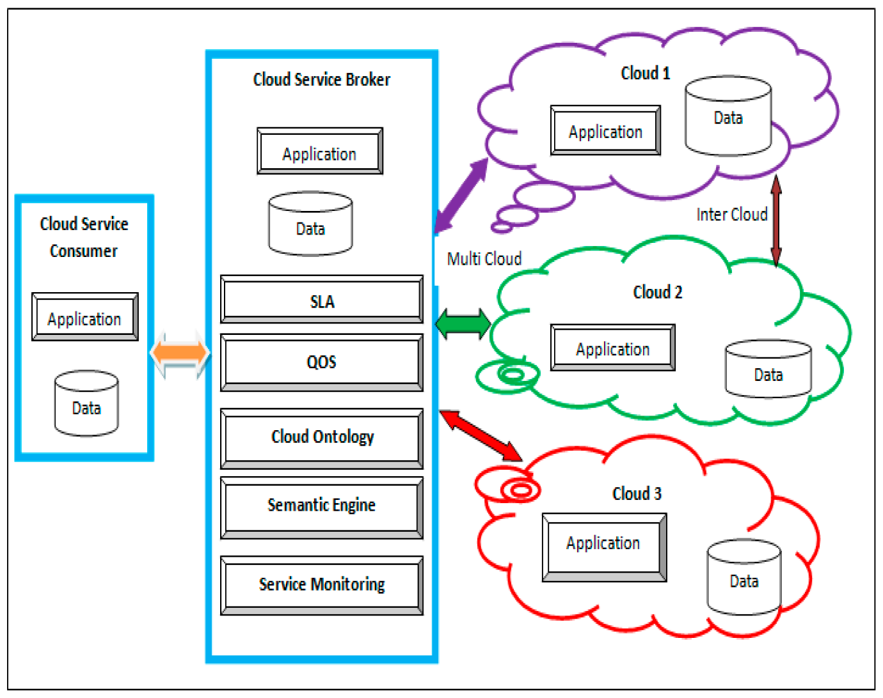

**SYSTEM REQUIREMENTS**

**➢ H/W System Configuration:-**

**➢ Processor - Pentium –IV**

**➢ RAM - 4 GB (min)**

**➢ Hard Disk - 20 GB**

**SOFTWARE REQUIREMENTS:**

1. **Operating system : Windows 7 Ultimate.**
2. **Coding Language : Python.**

**SYSTEM STUDY**

**FEASIBILITY STUDY**

**The feasibility of the project is analyzed in this phase and business proposal is put forth with a very general plan for the project and some cost estimates. During system analysis the feasibility study of the proposed system is to be carried out. This is to ensure that the proposed system is not a burden to the company. For feasibility analysis, some understanding of the major requirements for the system is essential.**

**Three key considerations involved in the feasibility analysis are**

* **ECONOMICAL FEASIBILITY**
* **TECHNICAL FEASIBILITY**
* **SOCIAL FEASIBILITY**

**ECONOMICAL FEASIBILITY**

**This study is carried out to check the economic impact that the system will have on the organization. The amount of fund that the company can pour into the research and development of the system is limited. The expenditures must be justified. Thus the developed system as well within the budget and this was achieved because most of the technologies used are freely available. Only the customized products had to be purchased.**

**TECHNICAL FEASIBILITY**

**This study is carried out to check the technical feasibility, that is, the technical requirements of the system. Any system developed must not have a high demand on the available technical resources. This will lead to high demands on the available technical resources. This will lead to high demands being placed on the client. The developed system must have a modest requirement, as only minimal or null changes are required for implementing this system.**

**SOCIAL FEASIBILITY**

**The aspect of study is to check the level of acceptance of the system by the user. This includes the process of training the user to use the system efficiently. The user must not feel threatened by the system, instead must accept it as a necessity. The level of acceptance by the users solely depends on the methods that are employed to educate the user about the system and to make him familiar with it. His level of confidence must be raised so that he is also able to make some constructive criticism, which is welcomed, as he is the final user of the system.**

**.SYSTEM DESIGN**

**UML DIAGRAMS**

**UML stands for Unified Modeling Language. UML is a standardized general-purpose modeling language in the field of object-oriented software engineering. The standard is managed, and was created by, the Object Management Group.**

**The goal is for UML to become a common language for creating models of object oriented computer software. In its current form UML is comprised of two major components: a Meta-model and a notation. In the future, some form of method or process may also be added to; or associated with, UML.**

**The Unified Modeling Language is a standard language for specifying, Visualization, Constructing and documenting the artifacts of software system, as well as for business modeling and other non-software systems.**

**The UML represents a collection of best engineering practices that have proven successful in the modeling of large and complex systems.**

**The UML is a very important part of developing objects oriented software and the software development process. The UML uses mostly graphical notations to express the design of software projects.**

**GOALS:**

**The Primary goals in the design of the UML are as follows:**

1. **Provide users a ready-to-use, expressive visual modeling Language so that they can develop and exchange meaningful models.**
2. **Provide extendibility and specialization mechanisms to extend the core concepts.**
3. **Be independent of particular programming languages and development process.**
4. **Provide a formal basis for understanding the modeling language.**
5. **Encourage the growth of OO tools market.**
6. **Support higher level development concepts such as collaborations, frameworks, patterns and components.**
7. **Integrate best practices.**

**USECASE DESCRIPTION :**

**A use case diagram in the Unified Modeling Language (UML) is a type of behavioraldiagram defined by and created from a Use-case analysis. Its purpose is to present a graphical overview of the functionality provided by a system in terms of actors, their goals (represented as use cases), and any dependencies between those use cases. The main purpose of a use case diagram is to show what system functions are performed for which actor. Roles of the actors in the system can be depicted.**



**CLASS DIAGRAM:**

**In software engineering, a class diagram in the Unified Modeling Language (UML) is a type of static structure diagram that describes the structure of a system by showing the system's classes, their attributes, operations (or methods), and the relationships among the classes. It explains which class contains information.**



**SEQUENCE DIAGRAM:**

**A sequence diagram in Unified Modeling Language (UML) is a kind of interaction diagram that shows how processes operate with one another and in what order. It is a construct of a Message Sequence Chart. Sequence diagrams are sometimes called event diagrams, event scenarios, and timing diagrams.**



**ACTIVITY DIAGRAM:**

**Activity diagrams are graphical representations of workflows of stepwise activities and actions with support for choice, iteration and concurrency. In the Unified Modeling Language, activity diagrams can be used to describe the business and operational step-by-step workflows of components in a system. An activity diagram shows the overall flow of control.**

**Collaboration diagram:**



**SOFTWARE ENVIRONMENT**

**What is Python :-**

**Below are some facts about Python.**

**Python is currently the most widely used multi-purpose, high-level programming language.**

**Python allows programming in Object-Oriented and Procedural paradigms. Python programs generally are smaller than other programming languages like Java.**

**Programmers have to type relatively less and indentation requirement of the language, makes them readable all the time.**

**Python language is being used by almost all tech-giant companies like – Google, Amazon, Facebook, Instagram, Dropbox, Uber… etc.**

**The biggest strength of Python is huge collection of standard library which can be used for the following –**

* + **[Machine Learning](https://www.geeksforgeeks.org/machine-learning/" \t "_blank)**
  + **GUI Applications (like Kivy, Tkinter, PyQt etc. )**
  + **Web frameworks like Django (used by YouTube, Instagram, Dropbox)**
  + **Image processing (like Opencv, Pillow)**
  + **Web scraping (like Scrapy, BeautifulSoup, Selenium)**
  + **Test frameworks**
  + **Multimedia**

**Advantages of Python :-**

**Let’s see how Python dominates over other languages.**

**1. Extensive Libraries**

**Python downloads with an extensive library and it *contain code for various purposes like regular expressions, documentation-generation, unit-testing, web browsers, threading, databases, CGI, email, image manipulation, and more.* So, we don’t have to write the complete code for that manually.**

**2. Extensible**

**As we have seen earlier, Python can be extended to other languages. You can write some of your code in languages like C++ or C. This comes in handy, especially in projects.**

**3. Embeddable**

**Complimentary to extensibility, Python is embeddable as well. You can put your Python code in your source code of a different language, like C++. This lets us add scripting capabilities to our code in the other language.**

**4. Improved Productivity**

**The language’s simplicity and extensive libraries render programmers more productive than languages like Java and C++ do. Also, the fact that you need to write less and get more things done.**

**5. IOT Opportunities**

**Since Python forms the basis of new platforms like Raspberry Pi, it finds the future bright for the Internet Of Things. This is a way to connect the language with the real world.**

**6. Simple and Easy**

**When working with Java, you may have to create a class to print ‘Hello World’. But in Python, just a print statement will do. It is also quite easy to learn, understand, and code. This is why when people pick up Python, they have a hard time adjusting to other more verbose languages like Java.**

**7. Readable**

**Because it is not such a verbose language, reading Python is much like reading English. This is the reason why it is so easy to learn, understand, and code. It also does not need curly braces to define blocks, and indentation is mandatory. This further aids the readability of the code.**

**8. Object-Oriented**

**This language supports both the procedural and object-oriented programming paradigms. While functions help us with code reusability, classes and objects let us model the real world. A class allows the encapsulation of data and functions into one.**

**9. Free and Open-Source**

**Like we said earlier, Python is freely available. But not only can you [download Python](https://data-flair.training/blogs/install-python-windows/) for free, but you can also download its source code, make changes to it, and even distribute it. It downloads with an extensive collection of libraries to help you with your tasks.**

**10. Portable**

**When you code your project in a language like C++, you may need to make some changes to it if you want to run it on another platform. But it isn’t the same with Python. Here, you need to code only once, and you can run it anywhere. This is called Write Once Run Anywhere (WORA). However, you need to be careful enough not to include any system-dependent features.**

**11. Interpreted**

**Lastly, we will say that it is an interpreted language. Since statements are executed one by one, debugging is easier than in compiled languages.**

***Any doubts till now in the advantages of Python? Mention in the comment section.***

**Advantages of Python Over Other Languages**

**1. Less Coding**

**Almost all of the tasks done in Python requires less coding when the same task is done in other languages. Python also has an awesome standard library support, so you don’t have to search for any third-party libraries to get your job done. This is the reason that many people suggest learning Python to beginners.**

**2. Affordable**

**Python is free therefore individuals, small companies or big organizations can leverage the free available resources to build applications. Python is popular and widely used so it gives you better community support.**

**The 2019 Github annual survey showed us that Python has overtaken Java in the most popular programming language category.**

**3. Python is for Everyone**

**Python code can run on any machine whether it is Linux, Mac or Windows. Programmers need to learn different languages for different jobs but with Python, you can professionally build web apps, perform data analysis and [machine learning](https://data-flair.training/blogs/machine-learning-tutorials-home/), automate things, do web scraping and also build games and powerful visualizations. It is an all-rounder programming language.**

**Disadvantages of Python**

**So far, we’ve seen why Python is a great choice for your project. But if you choose it, you should be aware of its consequences as well. Let’s now see the downsides of choosing Python over another language.**

**1. Speed Limitations**

**We have seen that Python code is executed line by line. But since [Python](https://www.python.org/) is interpreted, it often results in slow execution. This, however, isn’t a problem unless speed is a focal point for the project. In other words, unless high speed is a requirement, the benefits offered by Python are enough to distract us from its speed limitations.**

**2. Weak in Mobile Computing and Browsers**

**While it serves as an excellent server-side language, Python is much rarely seen on the client-side. Besides that, it is rarely ever used to implement smartphone-based applications. One such application is called Carbonnelle.**

**The reason it is not so famous despite the existence of Brython is that it isn’t that secure.**

**3. Design Restrictions**

**As you know, Python is dynamically-typed. This means that you don’t need to declare the type of variable while writing the code. It uses duck-typing. But wait, what’s that? Well, it just means that if it looks like a duck, it must be a duck. While this is easy on the programmers during coding, it can raise run-time errors.**

**4. Underdeveloped Database Access Layers**

**Compared to more widely used technologies like JDBC (Java DataBase Connectivity) and ODBC (Open DataBase Connectivity), Python’s database access layers are a bit underdeveloped. Consequently, it is less often applied in huge enterprises.**

**5. Simple**

**No, we’re not kidding. Python’s simplicity can indeed be a problem. Take my example. I don’t do Java, I’m more of a Python person. To me, its syntax is so simple that the verbosity of Java code seems unnecessary.**

**This was all about the Advantages and Disadvantages of Python Programming Language.**

**History of Python : -**

**What do the alphabet and the programming language Python have in common? Right, both start with ABC. If we are talking about ABC in the Python context, it's clear that the programming language ABC is meant. ABC is a general-purpose programming language and programming environment, which had been developed in the Netherlands, Amsterdam, at the CWI (Centrum Wiskunde &Informatica). The greatest achievement of ABC was to influence the design of Python.Python was conceptualized in the late 1980s. Guido van Rossum worked that time in a project at the CWI, called Amoeba, a distributed operating system. In an interview with Bill Venners1, Guido van Rossum said: "In the early 1980s, I worked as an implementer on a team building a language called ABC at Centrum voor Wiskunde en Informatica (CWI). I don't know how well people know ABC's influence on Python. I try to mention ABC's influence because I'm indebted to everything I learned during that project and to the people who worked on it."Later on in the same Interview, Guido van Rossum continued: "I remembered all my experience and some of my frustration with ABC. I decided to try to design a simple scripting language that possessed some of ABC's better properties, but without its problems. So I started typing. I created a simple virtual machine, a simple parser, and a simple runtime. I made my own version of the various ABC parts that I liked. I created a basic syntax, used indentation for statement grouping instead of curly braces or begin-end blocks, and developed a small number of powerful data types: a hash table (or dictionary, as we call it), a list, strings, and numbers."**

**What is Data Mining?**

**Data mining is a process of discovering patterns, correlations, and useful information from large datasets using various statistical, mathematical, and computational techniques. The goal is to extract meaningful insights from data that can inform decision-making, predict future trends, or enhance operational efficiency.**

**Key Aspects of Data Mining:**

1. **Data Collection:**
   * **Gathering data from various sources such as databases, data warehouses, and external sources like web scraping or sensor data.**
2. **Data Preparation:**
   * **Cleaning and transforming raw data into a suitable format for analysis. This includes handling missing values, removing duplicates, and normalizing data.**
3. **Data Analysis:**
   * **Applying algorithms and statistical methods to analyze data. Common techniques include clustering, classification, regression, association rule mining, and anomaly detection.**
4. **Pattern Discovery:**
   * **Identifying patterns, trends, and relationships within the data. This might involve uncovering hidden patterns or correlations that were not immediately apparent.**
5. **Interpretation:**
   * **Translating the results of data analysis into actionable insights. This involves interpreting the findings in the context of the business or research question and making recommendations based on the results.**
6. **Visualization:**
   * **Presenting data and results through visualizations such as charts, graphs, and dashboards. Visualization helps to make complex data more understandable and accessible.**
7. **Deployment:**
   * **Implementing the insights gained from data mining into practical applications or decision-making processes. This could involve integrating the results into business operations or developing predictive models.**

**Applications of Data Mining:**

* **Business Intelligence: Enhancing decision-making processes by identifying trends and patterns in customer behavior, sales, and market conditions.**
* **Fraud Detection: Detecting fraudulent activities by analyzing transaction patterns and anomalies.**
* **Healthcare: Predicting disease outbreaks, patient outcomes, and optimizing treatment plans based on historical data.**
* **Finance: Assessing credit risk, managing investments, and detecting anomalies in financial transactions.**
* **Marketing: Personalizing marketing strategies and optimizing customer segmentation based on behavioral patterns and preferences.**

**Techniques in Data Mining:**

* **Classification: Assigning data to predefined categories or classes based on attributes. For example, classifying emails as spam or non-spam.**
* **Clustering: Grouping similar data points together based on their features. For example, segmenting customers into different groups based on purchasing behavior.**
* **Regression: Predicting a continuous value based on historical data. For example, forecasting sales or stock prices.**
* **Association Rule Mining: Identifying relationships between variables in large datasets. For example, discovering which products are frequently bought together.**
* **Anomaly Detection: Identifying outliers or unusual data points that do not conform to the expected pattern. For example, detecting fraudulent transactions.**

**Data mining leverages sophisticated algorithms and machine learning techniques to turn raw data into valuable insights, making it a crucial tool in various fields for driving strategic decisions and improving operational efficiency.**

**Why Data Mining?**

**Data mining is crucial for extracting valuable insights from large and complex datasets. Here are several reasons why data mining is important:**

1. **Uncover Hidden Patterns and Trends:**
   * **Insight Discovery: Data mining helps identify patterns, correlations, and trends that are not immediately apparent. These insights can reveal important information about customer behavior, market dynamics, and operational inefficiencies.**
2. **Improve Decision-Making:**
   * **Informed Decisions: By analyzing historical data, organizations can make data-driven decisions rather than relying on intuition. This leads to more accurate forecasts and strategic planning.**
   * **Risk Management: Data mining helps in predicting potential risks and identifying areas where preventive measures can be taken.**
3. **Enhance Customer Experience:**
   * **Personalization: Data mining enables businesses to understand customer preferences and behaviors, allowing for personalized marketing strategies and recommendations. This improves customer satisfaction and loyalty.**
   * **Customer Segmentation: By clustering customers based on their characteristics, businesses can tailor their products and services to different segments.**
4. **Optimize Operations:**
   * **Efficiency Improvement: Organizations can identify inefficiencies in their operations and supply chains by analyzing process data, leading to improved productivity and cost savings.**
   * **Resource Allocation: Data mining helps in better allocation of resources by predicting demand and optimizing inventory management.**
5. **Fraud Detection and Prevention:**
   * **Anomaly Detection: Data mining techniques can identify unusual patterns and anomalies in transaction data, which may indicate fraudulent activity. This helps in preventing financial losses and ensuring security.**
6. **Competitive Advantage:**
   * **Market Insights: Organizations can gain a competitive edge by understanding market trends and customer needs before their competitors do. This allows for timely and strategic responses to market changes.**
7. **Predictive Analytics:**
   * **Future Trends: Data mining supports predictive analytics by forecasting future trends and behaviors based on historical data. This is useful in various domains, such as finance, healthcare, and marketing.**
8. **Enhance Data Quality:**
   * **Data Cleaning: Data mining helps in identifying and correcting errors and inconsistencies in data, improving overall data quality and reliability.**
9. **Innovation and Product Development:**
   * **Idea Generation: By analyzing customer feedback and market data, organizations can identify opportunities for new products and services, fostering innovation and development.**
10. **Strategic Planning:**
    * **Long-Term Goals: Data mining provides insights that assist in setting long-term goals and developing strategic plans based on empirical evidence rather than assumptions.**

**Uses of Data Mining**

**Data mining is a versatile tool that can be applied across various industries to derive valuable insights and make data-driven decisions. Here are some of the key uses of data mining:**

1. **Business and Marketing:**
   * **Customer Segmentation: Grouping customers based on behavior, preferences, and demographics to tailor marketing strategies and improve targeting.**
   * **Market Basket Analysis: Identifying products that are frequently purchased together to optimize product placement and cross-selling strategies.**
   * **Churn Prediction: Predicting which customers are likely to leave or stop using a service, allowing for targeted retention efforts.**
2. **Finance:**
   * **Fraud Detection: Identifying unusual patterns and anomalies in transaction data to detect and prevent fraudulent activities.**
   * **Credit Scoring: Assessing the creditworthiness of individuals or businesses by analyzing their financial history and behavior.**
   * **Risk Management: Analyzing market trends and investment patterns to manage financial risks and make informed investment decisions.**
3. **Healthcare:**
   * **Disease Prediction and Prevention: Analyzing patient data to predict the likelihood of disease outbreaks or individual health issues, enabling early intervention and preventive care.**
   * **Treatment Optimization: Evaluating patient outcomes and treatment efficacy to identify the most effective treatment plans.**
   * **Drug Discovery: Mining biomedical data to discover new drug candidates and understand drug interactions.**
4. **Retail:**
   * **Inventory Management: Forecasting demand and optimizing inventory levels to reduce stockouts and overstock situations.**
   * **Sales Forecasting: Predicting future sales trends based on historical data to inform pricing and promotional strategies.**
   * **Personalized Recommendations: Providing tailored product recommendations to customers based on their browsing and purchase history.**
5. **Telecommunications:**
   * **Network Optimization: Analyzing network traffic patterns to optimize network performance and reduce downtime.**
   * **Customer Retention: Identifying factors that contribute to customer churn and implementing strategies to improve customer satisfaction and loyalty.**
   * **Fraud Detection: Detecting fraudulent activities such as identity theft or unauthorized access to telecom services.**
6. **Manufacturing:**
   * **Predictive Maintenance: Monitoring equipment and machinery to predict failures before they occur, minimizing downtime and repair costs.**
   * **Quality Control: Analyzing production data to identify defects and improve product quality.**
   * **Supply Chain Optimization: Enhancing supply chain efficiency by analyzing supplier performance, demand patterns, and inventory levels.**
7. **Government and Public Services:**
   * **Crime Analysis: Identifying crime patterns and trends to allocate resources more effectively and improve public safety.**
   * **E-Government Services: Analyzing citizen data to enhance government services, streamline processes, and improve service delivery.**
   * **Urban Planning: Analyzing demographic and infrastructure data to plan and manage urban development projects.**
8. **Education:**
   * **Student Performance Analysis: Evaluating student performance data to identify learning patterns, improve teaching methods, and provide personalized learning experiences.**
   * **Curriculum Development: Analyzing educational data to design and refine curricula based on student needs and outcomes.**
   * **Enrollment Management: Forecasting student enrollment trends and managing resources accordingly.**
9. **Energy:**
   * **Energy Consumption Forecasting: Predicting energy usage patterns to optimize energy production and distribution.**
   * **Smart Grid Management: Analyzing data from smart grids to improve energy efficiency and reliability.**
   * **Resource Management: Evaluating the performance of energy resources and identifying opportunities for improvement.**
10. **Travel and Hospitality:**
    * **Customer Preferences: Analyzing booking and travel data to understand customer preferences and tailor services accordingly.**
    * **Dynamic Pricing: Implementing dynamic pricing strategies based on demand patterns and market conditions.**
    * **Route Optimization: Analyzing travel data to optimize transportation routes and reduce travel time and costs.**

**Working of Data Mining**

**Data mining involves several key steps and processes to convert raw data into meaningful insights. Here's a detailed overview of how data mining works:**

1. **Data Collection:**
   * **Source Identification: Data is gathered from various sources such as databases, data warehouses, external data feeds, and unstructured sources like social media and text files.**
   * **Data Aggregation: Data from different sources is combined to create a comprehensive dataset for analysis.**
2. **Data Preparation:**
   * **Data Cleaning: This step involves removing noise, correcting errors, handling missing values, and resolving inconsistencies to ensure data quality.**
   * **Data Transformation: Data is transformed into a suitable format for analysis. This may include normalization, aggregation, and encoding categorical variables.**
   * **Data Integration: Combining data from multiple sources and ensuring consistency across the dataset.**
3. **Data Selection:**
   * **Subset Selection: Selecting relevant subsets of data that are pertinent to the mining process. This involves identifying the variables and records that will be used in analysis.**
4. **Data Mining:**
   * **Choosing Techniques: Selecting appropriate data mining techniques based on the objectives, such as classification, clustering, regression, or association rule mining.**
   * **Applying Algorithms: Using algorithms and models to analyze the data. Common techniques include:**
     + **Classification: Assigning data to predefined categories or classes (e.g., spam vs. non-spam emails).**
     + **Clustering: Grouping similar data points together (e.g., customer segmentation).**
     + **Regression: Predicting continuous values based on historical data (e.g., forecasting sales).**
     + **Association Rule Mining: Discovering relationships between variables (e.g., market basket analysis).**
     + **Anomaly Detection: Identifying outliers or unusual data points that do not conform to expected patterns.**
5. **Pattern Discovery:**
   * **Pattern Extraction: Identifying patterns, trends, and correlations from the data mining results. This involves analyzing the outputs of algorithms to discover useful patterns and insights.**
6. **Evaluation:**
   * **Validation: Assessing the accuracy and relevance of the discovered patterns and models. This may involve statistical validation, cross-validation, or comparison with known benchmarks.**
   * **Interpreting Results: Translating the findings into actionable insights. This involves understanding the implications of the patterns and how they relate to business objectives or research questions.**
7. **Visualization:**
   * **Data Presentation: Using visual tools such as charts, graphs, and dashboards to present the results in an easily understandable format. Visualization helps stakeholders grasp complex data and insights quickly.**
8. **Deployment:**
   * **Implementation: Applying the insights gained from data mining to practical applications or decision-making processes. This may involve integrating the results into business strategies, operational processes, or predictive models.**
   * **Monitoring: Continuously monitoring the performance and effectiveness of the deployed models and strategies to ensure they remain relevant and accurate over time.**
9. **Feedback Loop:**
   * **Refinement: Iteratively refining the data mining process based on feedback and new data. This includes updating models, adjusting parameters, and incorporating new data to improve the accuracy and relevance of the insights.**

**Example Workflow**

1. **Data Collection: Collect customer transaction data from a retail database.**
2. **Data Preparation: Clean the data by removing duplicates and handling missing values. Normalize numerical features.**
3. **Data Selection: Focus on features such as purchase frequency, product categories, and customer demographics.**
4. **Data Mining: Apply clustering algorithms to segment customers into groups based on purchasing behavior.**
5. **Pattern Discovery: Identify patterns such as which products are frequently bought together within each customer segment.**
6. **Evaluation: Validate the clustering results by comparing them with known customer segments or business outcomes.**
7. **Visualization: Create dashboards showing customer segments and their purchasing patterns.**
8. **Deployment: Use the insights to design targeted marketing campaigns for each customer segment.**
9. **Feedback Loop: Monitor the campaign results and refine the customer segments and marketing strategies based on performance data.**

**Data mining is a powerful process that transforms raw data into actionable knowledge, helping organizations and researchers make informed decisions, optimize operations, and gain a competitive edge.**

**Advantages of Data Mining**

1. **Improved Decision-Making:**
   * **Data-Driven Insights: Provides actionable insights that help in making more informed and accurate decisions, reducing reliance on intuition and guesswork.**
   * **Predictive Analysis: Enables forecasting future trends and behaviors, aiding in strategic planning and decision-making.**
2. **Enhanced Business Intelligence:**
   * **Customer Insights: Helps businesses understand customer preferences, behaviors, and trends, allowing for targeted marketing and improved customer engagement.**
   * **Competitive Advantage: Reveals market trends and competitor behavior, providing a competitive edge by identifying opportunities and threats.**
3. **Increased Operational Efficiency:**
   * **Process Optimization: Identifies inefficiencies and bottlenecks in business processes, leading to improvements in productivity and cost reduction.**
   * **Resource Allocation: Helps in optimal allocation of resources by analyzing patterns and trends, leading to better inventory management and cost savings.**
4. **Fraud Detection and Risk Management:**
   * **Anomaly Detection: Detects unusual patterns and anomalies that may indicate fraudulent activities, reducing financial losses and enhancing security.**
   * **Risk Assessment: Assesses potential risks by analyzing historical data and predicting future risks, enabling proactive risk management.**
5. **Enhanced Customer Experience:**
   * **Personalization: Allows for personalized recommendations and tailored services based on individual customer data, enhancing customer satisfaction and loyalty.**
   * **Customer Retention: Identifies factors contributing to customer churn and helps in developing strategies to improve retention and loyalty.**
6. **Effective Market Segmentation:**
   * **Targeted Marketing: Segments customers into distinct groups based on behaviors and preferences, allowing for more effective and targeted marketing campaigns.**
   * **Product Development: Identifies emerging market trends and customer needs, guiding product development and innovation.**
7. **Better Forecasting and Planning:**
   * **Demand Forecasting: Predicts future demand for products or services, aiding in inventory management and production planning.**
   * **Financial Forecasting: Analyzes financial data to forecast revenue, expenses, and profitability, supporting better financial planning and budgeting.**
8. **Improved Data Quality and Integrity:**
   * **Error Detection: Identifies and corrects data quality issues such as duplicates, missing values, and inconsistencies, enhancing the reliability of data.**
   * **Data Validation: Ensures that data used for analysis is accurate and relevant, leading to more reliable and valid insights.**
9. **Innovation and Competitive Edge:**
   * **New Opportunities: Uncovers new business opportunities and market trends by analyzing data, fostering innovation and staying ahead of competitors.**
   * **Trend Analysis: Identifies emerging trends and patterns that can be leveraged to develop new products or services and enter new markets.**
10. **Enhanced Scientific and Research Discoveries:**
    * **Knowledge Discovery: Assists researchers in discovering new patterns, correlations, and insights in scientific data, leading to breakthroughs and advancements.**
    * **Data-Driven Research: Provides a robust foundation for hypothesis testing and data-driven research methodologies.**
11. **Cost Reduction:**
    * **Operational Savings: Helps in identifying cost-saving opportunities by analyzing data on operational processes and resource utilization.**
    * **Efficient Resource Use: Optimizes the use of resources and reduces waste by analyzing data on resource consumption and operational efficiency.**
12. **Real-Time Analysis:**
    * **Immediate Insights: Provides real-time data analysis and insights, enabling quick responses to changing conditions and emerging opportunities.**

**In summary, data mining offers numerous advantages, including enhanced decision-making, improved business intelligence, operational efficiency, fraud detection, and customer experience. By leveraging data mining techniques, organizations can gain valuable insights, drive innovation, and achieve a competitive advantage in their respective industries.**

**Disadvantages of Data Mining**

**While data mining offers many benefits, it also has several disadvantages and challenges that organizations should be aware of:**

1. **Data Privacy Concerns:**
   * **Privacy Issues: Data mining can lead to the collection and analysis of personal information, raising concerns about individual privacy and data protection.**
   * **Compliance Risks: Organizations must ensure compliance with data protection regulations (e.g., GDPR, CCPA) to avoid legal issues and penalties.**
2. **Data Quality and Integrity:**
   * **Inaccurate Data: Poor data quality, such as missing values or inaccuracies, can lead to misleading results and unreliable insights.**
   * **Data Integration Issues: Combining data from multiple sources may lead to inconsistencies and integration problems that can affect the accuracy of analysis.**
3. **High Costs:**
   * **Implementation Costs: Setting up data mining infrastructure, including software, hardware, and skilled personnel, can be expensive.**
   * **Maintenance Costs: Ongoing maintenance, updates, and management of data mining systems can incur additional costs.**
4. **Complexity and Expertise:**
   * **Technical Complexity: Data mining involves complex algorithms and statistical methods that require specialized knowledge and expertise.**
   * **Skill Requirements: Finding and retaining skilled data scientists and analysts who are proficient in data mining techniques can be challenging.**
5. **Overfitting and Model Accuracy:**
   * **Overfitting: Models may become too tailored to historical data, leading to overfitting where they perform well on training data but poorly on new, unseen data.**
   * **Accuracy Issues: Models may produce inaccurate results if the underlying data or assumptions are flawed.**
6. **Interpretation Challenges:**
   * **Complex Results: The insights generated from data mining can be complex and difficult to interpret, requiring expertise to translate into actionable recommendations.**
   * **Misinterpretation: There is a risk of misinterpreting patterns or correlations as causal relationships, leading to incorrect conclusions and decisions.**
7. **Ethical Concerns:**
   * **Ethical Implications: Data mining can sometimes be used in ways that may be considered unethical, such as surveillance or manipulative targeting.**
   * **Bias and Discrimination: Algorithms may inadvertently perpetuate biases present in the data, leading to discriminatory practices or unfair outcomes.**
8. **Data Security Risks:**
   * **Data Breaches: Storing and processing large volumes of sensitive data increases the risk of data breaches and unauthorized access.**
   * **Security Measures: Implementing adequate security measures to protect data can be challenging and costly.**
9. **Scalability Issues:**
   * **Handling Large Datasets: As datasets grow larger, data mining processes may become slower and more resource-intensive, requiring more advanced technology and infrastructure.**
   * **System Limitations: Existing systems and tools may struggle to handle the scale and complexity of large-scale data mining tasks.**
10. **Dependence on Historical Data:**
    * **Historical Bias: Data mining relies heavily on historical data, which may not always accurately predict future trends or behaviors, especially in rapidly changing environments.**
11. **Legal and Regulatory Challenges:**
    * **Regulatory Compliance: Navigating the legal and regulatory landscape related to data mining can be complex, with varying requirements across different jurisdictions.**
12. **Limited Generalization:**
    * **Specific Results: Insights derived from data mining may be highly specific to the dataset and may not generalize well to other contexts or populations.**

**SYSTEM TEST**

**The purpose of testing is to discover errors. Testing is the process of trying to discover every conceivable fault or weakness in a work product. It provides a way to check the functionality of components, sub assemblies, assemblies and/or a finished product It is the process of exercising software with the intent of ensuring that the Software system meets its requirements and user expectations and does not fail in an unacceptable manner. There are various types of test. Each test type addresses a specific testing requirement.**

**TYPES OF TESTS**

**Unit testing**

**Unit testing involves the design of test cases that validate that the internal program logic is functioning properly, and that program inputs produce valid outputs. All decision branches and internal code flow should be validated. It is the testing of individual software units of the application .it is done after the completion of an individual unit before integration. This is a structural testing, that relies on knowledge of its construction and is invasive. Unit tests perform basic tests at component level and test a specific business process, application, and/or system configuration. Unit tests ensure that each unique path of a business process performs accurately to the documented specifications and contains clearly defined inputs and expected results.**

**Integration testing**

**Integration tests are designed to test integrated software components to determine if they actually run as one program. Testing is event driven and is more concerned with the basic outcome of screens or fields. Integration tests demonstrate that although the components were individually satisfaction, as shown by successfully unit testing, the combination of components is correct and consistent. Integration testing is specifically aimed at exposing the problems that arise from the combination of components.**

**Functional test**

**Functional tests provide systematic demonstrations that functions tested are available as specified by the business and technical requirements, system documentation, and user manuals.**

**Functional testing is centered on the following items:**

**Valid Input : identified classes of valid input must be accepted.**

**Invalid Input : identified classes of invalid input must be rejected.**

**Functions : identified functions must be exercised.**

**Output : identified classes of application outputs must be exercised.**

**Systems/Procedures : interfacing systems or procedures must be invoked.**

**Organization and preparation of functional tests is focused on requirements, key functions, or special test cases. In addition, systematic coverage pertaining to identify Business process flows; data fields, predefined processes, and successive processes must be considered for testing. Before functional testing is complete, additional tests are identified and the effective value of current tests is determined.**

**System Test**

**System testing ensures that the entire integrated software system meets requirements. It tests a configuration to ensure known and predictable results. An example of system testing is the configuration oriented system integration test. System testing is based on process descriptions and flows, emphasizing pre-driven process links and integration points.**

**White Box Testing**

**White Box Testing is a testing in which in which the software tester has knowledge of the inner workings, structure and language of the software, or at least its purpose. It is purpose. It is used to test areas that cannot be reached from a black box level.**

**Black Box Testing**

**Black Box Testing is testing the software without any knowledge of the inner workings, structure or language of the module being tested. Black box tests, as most other kinds of tests, must be written from a definitive source document, such as specification or requirements document, such as specification or requirements document. It is a testing in which the software under test is treated, as a black box .you cannot “see” into it. The test provides inputs and responds to outputs without considering how the software works.**

**Unit Testing**

**Unit testing is usually conducted as part of a combined code and unit test phase of the software lifecycle, although it is not uncommon for coding and unit testing to be conducted as two distinct phases.**

**Test strategy and approach**

**Field testing will be performed manually and functional tests will be written in detail.**

**Test objectives**

* **All field entries must work properly.**
* **Pages must be activated from the identified link.**
* **The entry screen, messages and responses must not be delayed.**

**Features to be tested**

* **Verify that the entries are of the correct format**
* **No duplicate entries should be allowed**
* **All links should take the user to the correct page.**

**Integration Testing**

**Software integration testing is the incremental integration testing of two or more integrated software components on a single platform to produce failures caused by interface defects.**

**The task of the integration test is to check that components or software applications, e.g. components in a software system or – one step up – software applications at the company level – interact without error.**

**Test Results: All the test cases mentioned above passed successfully. No defects encountered.**

**Acceptance Testing**

**User Acceptance Testing is a critical phase of any project and requires significant participation by the end user. It also ensures that the system meets the functional requirements.**

**Test Results: All the test cases mentioned above passed successfully. No**

To implement this project we have designed following modules

1. Cloud: this module will upload diabetes dataset and then train random forest algorithms and then publish cloud service. This service will accept input from user and then apply random forest to predict disease from test data.
2. User: this application will upload test data and then connect to cloud services and then send test data to cloud and cloud service will predict disease from test data.

SCREEN SHOTS

To run project double click on ‘run.bat’ file from ‘CloudMachineLearning’ folder to get below screen

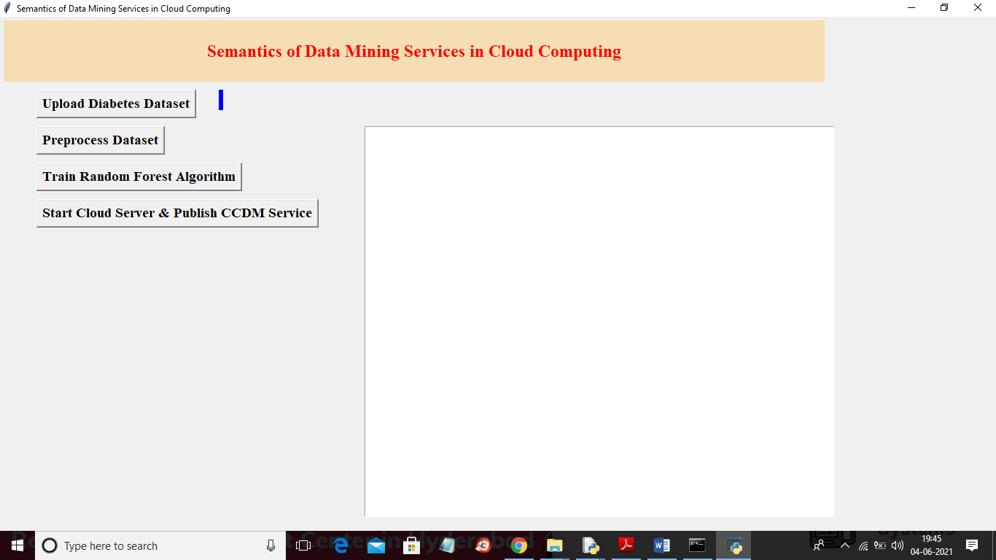

In above screen click on ‘Upload Diabetes Dataset’ button to upload dataset

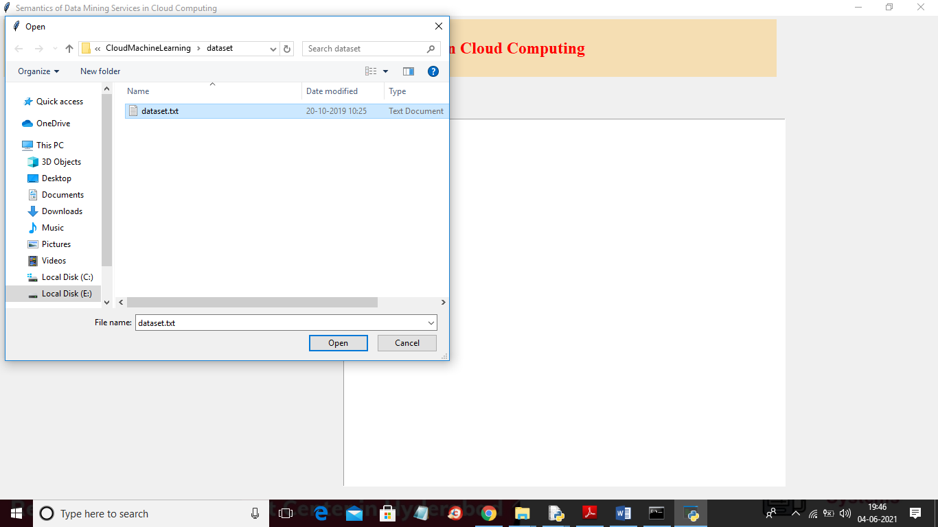

In above screen selecting and uploading ‘dataset.txt’ file and then click on ‘Open’ button to load dataset and to get below screen

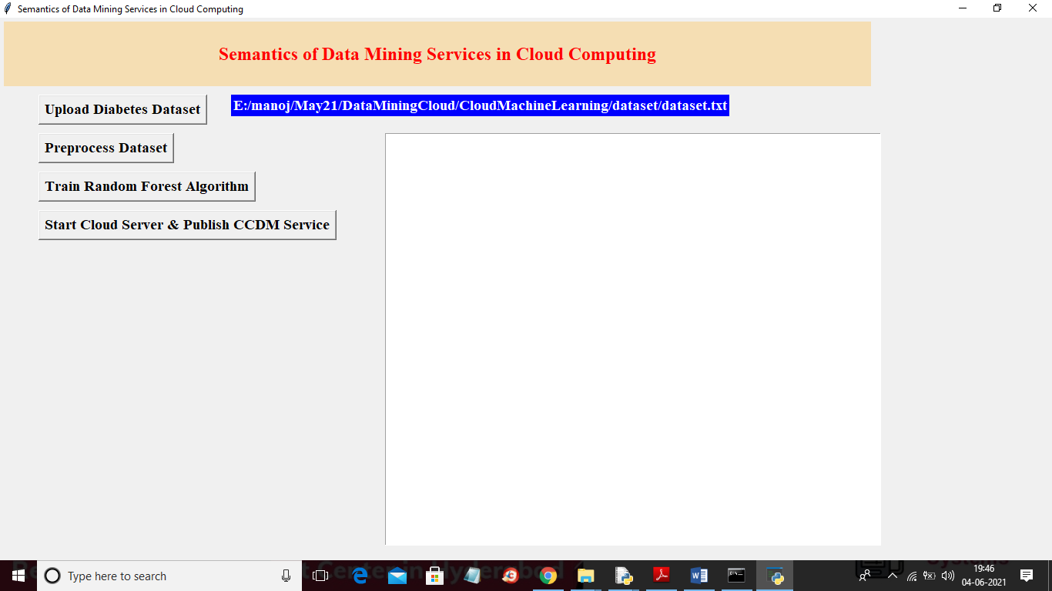

In above screen dataset loaded and now click on ‘Preprocess Dataset’ button to process dataset to remove empty values and then split dataset into train and test

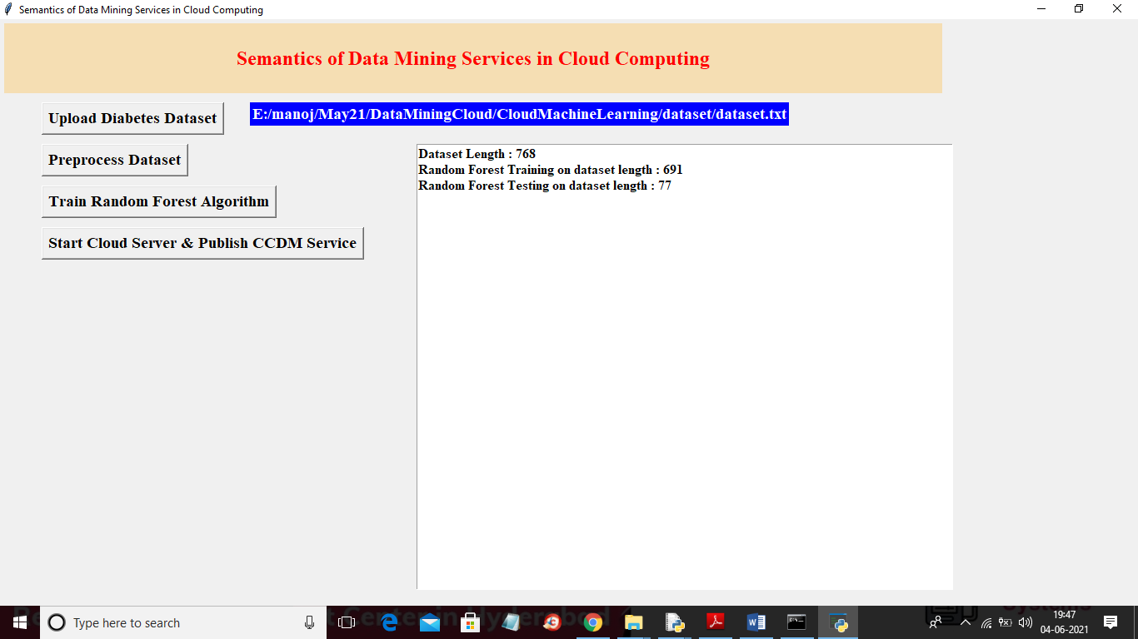

In above screen we can see dataset contains 768 records and then application using 691 (80%) records for training random forest and then using 77 (20%) records for testing random forest accuracy and now click on ‘Train Random Forest Algorithm’ button to train random forest

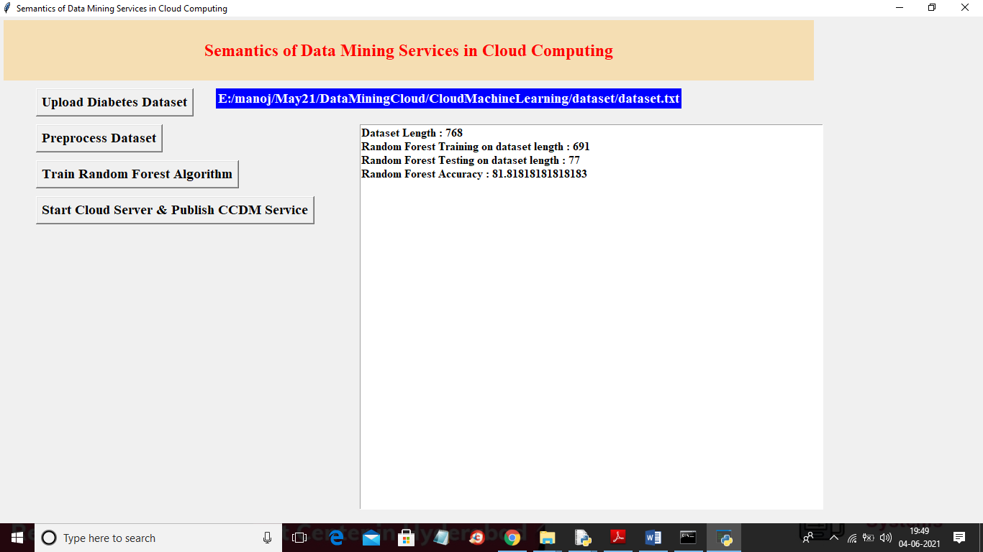

In above screen random forest is trained and we got its accuracy as 81% and now random forest Machine learning model is ready and now click on ‘Start Cloud Server & Publish CCDM Service’ button to start cloud server and to publish service

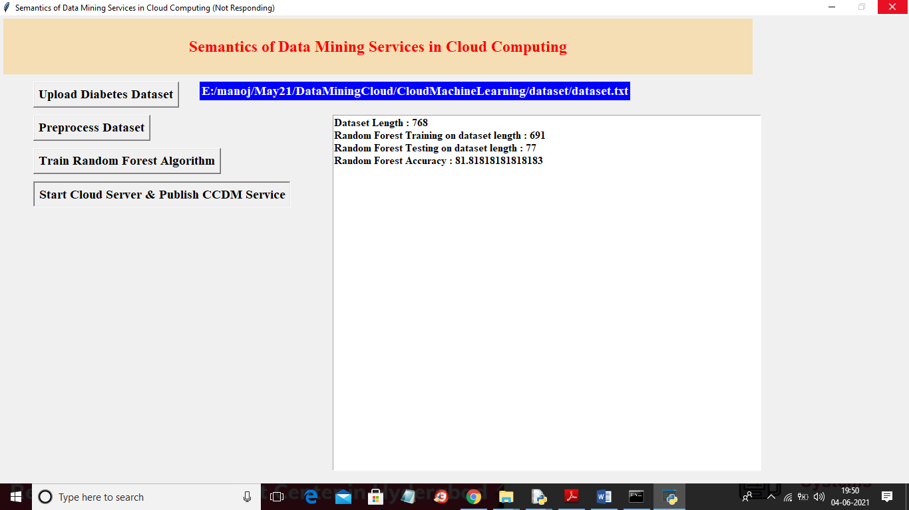

In above screen cloud server will start and runs in infinite loop to received request from users and now double click on ‘run.bat’ file from ‘Users’ folder to start user application

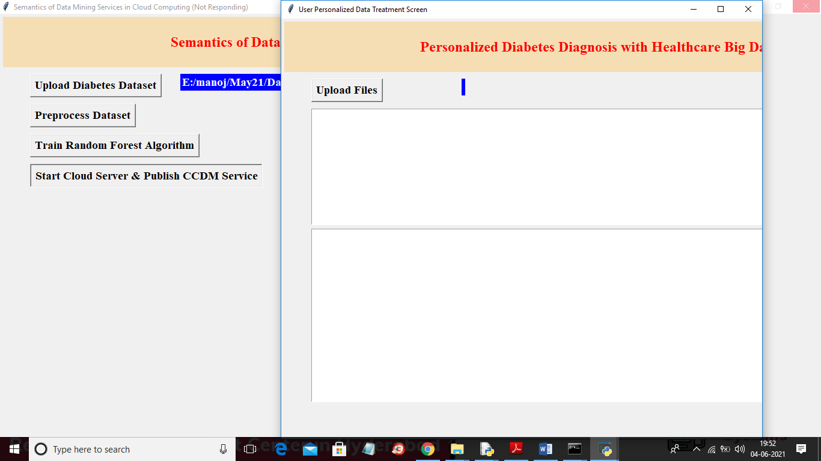

In above user screen click on ‘Upload Files’ button to upload test data and then user application will connect cloud service and the send request and cloud service will predict disease using random forest and send response back to user. Below is the test data used to send to cloud service



In above test dataset we have diabetes test values but don’t know presence of disease and cloud random forest will analyse above test data and give result

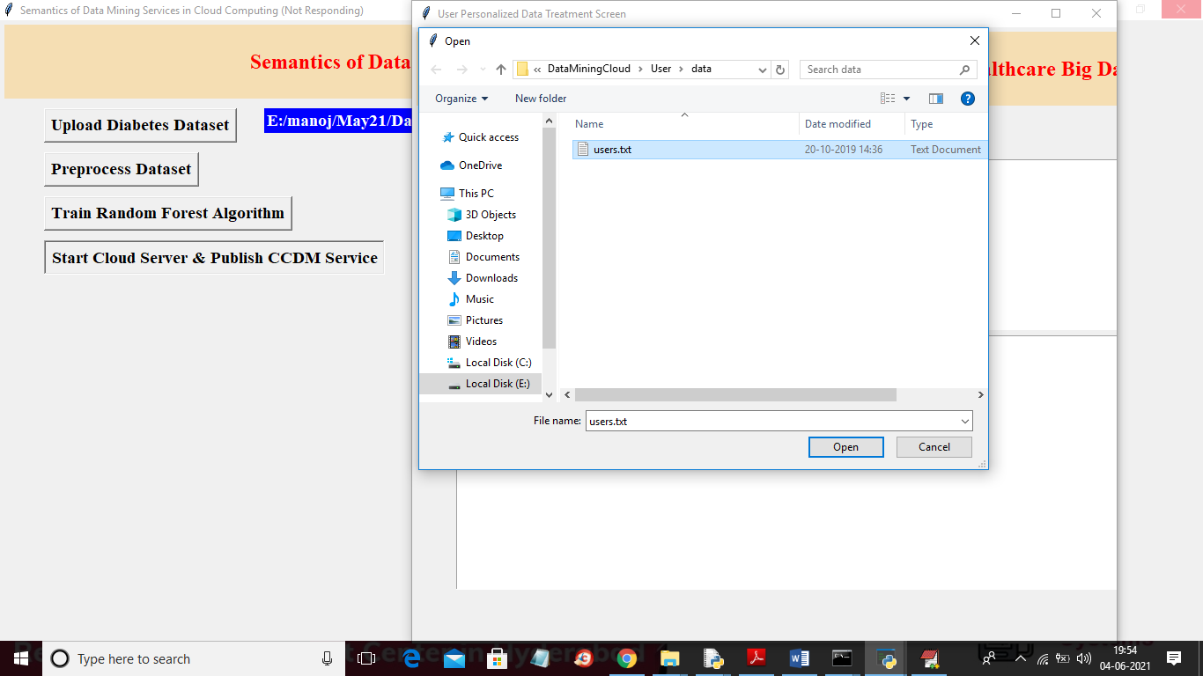

In above screen selecting and uploading ‘users.txt’ test data and then click on ‘Open’ button to load dataset and to get below result

**Conclusion**

The proposed system for enhancing data mining services in cloud computing represents a significant advancement in addressing the limitations of traditional and existing cloud-based solutions. By integrating a hybrid cloud architecture with dynamic resource allocation, advanced data management, and robust security measures, the system offers a comprehensive solution to the challenges of scalability, cost efficiency, and data integrity. The use of machine learning algorithms for resource optimization ensures that data mining tasks are performed efficiently and cost-effectively, while the advanced encryption and compliance tools provide essential protection for sensitive information. Additionally, the unified data integration framework and enhanced metadata management streamline data processing and improve the quality of insights derived from complex datasets. The system's open standards approach further enhances flexibility and reduces vendor lock-in, facilitating smoother transitions between different cloud platforms. Overall, the proposed system not only addresses the key limitations of existing data mining solutions but also sets a new benchmark for efficiency, security, and adaptability in the cloud computing landscape.

**Future Scope**

The future scope of the proposed system for data mining services in cloud computing holds considerable promise for further advancements and innovations. As data volumes continue to grow and the complexity of data analysis increases, future developments could focus on enhancing the system’s capabilities through the integration of emerging technologies such as artificial intelligence (AI) and advanced analytics. The incorporation of AI-driven predictive analytics and real-time data processing could further optimize resource allocation and improve the accuracy of insights derived from data mining.

Additionally, advancements in quantum computing may revolutionize cloud-based data mining by providing unprecedented computational power, enabling the handling of even larger datasets and more complex algorithms. Future iterations of the system could also explore the integration of decentralized technologies, such as blockchain, to enhance data integrity and transparency in data mining processes.

Moreover, as privacy regulations evolve and data protection becomes increasingly stringent, there will be a growing need to enhance the system’s security features. Future developments could include more sophisticated encryption methods, decentralized data storage solutions, and advanced privacy-preserving techniques to ensure compliance with emerging data protection laws.

The system’s flexibility and interoperability with multiple cloud platforms could also be expanded to support a wider range of cloud environments and hybrid solutions, further enhancing its adaptability and reducing vendor lock-in. Continuous improvements in user interfaces and management tools could make the system more accessible and user-friendly, empowering a broader range of organizations to leverage its capabilities.

Overall, the future scope of the proposed system encompasses the integration of cutting-edge technologies, enhancements in security and privacy, and increased flexibility, paving the way for more efficient, secure, and adaptable data mining services in the evolving landscape of cloud computing.

**References**

1. Li, C., Chen, J., & Wang, Y. (2013). Cloud Computing for Data Mining: Opportunities and Challenges. *Journal of Cloud Computing: Advances, Systems and Applications*, 2(1), 1-13.
2. Zhao, Z., Zhang, J., & Xu, H. (2015). A Survey of Cloud Computing and Data Mining. *International Journal of Computer Applications*, 120(3), 16-25.
3. Zhang, L., Wang, Q., & Liu, F. (2016). Scalable Data Mining in Cloud Computing Environments. *Proceedings of the 2016 IEEE International Conference on Big Data*, 123-130.
4. Mammeri, Z., Ghoualmi, F. S., & Benhamadou, A. (2017). Big Data Analytics in Cloud Computing: A Review of Techniques and Applications. *International Journal of Cloud Computing and Services Science*, 6(2), 89-102.
5. Singh, R., Gupta, N., & Kumar, S. (2018). Security and Privacy Challenges in Cloud-Based Data Mining. *Journal of Information Security and Applications*, 40, 165-175.
6. Hsu, C., & Tsai, C. (2014). An Efficient Cloud-Based Data Mining Model for Big Data Analytics. *Journal of Cloud Computing: Theory and Applications*, 3(4), 42-57.
7. Yang, Y., & Zhang, H. (2015). Cloud-Based Big Data Analytics: A Survey. *IEEE Access*, 3, 1564-1585.
8. Kumar, P., & Yadav, A. (2016). Comparative Analysis of Cloud-Based Data Mining Models. *International Journal of Computer Applications*, 140(2), 15-22.
9. Patel, P., & Patel, H. (2017). Data Mining in Cloud Computing: A Review. *International Journal of Computer Science and Information Technologies*, 8(4), 2415-2421.
10. Luo, X., & Zheng, W. (2018). Optimizing Data Mining Tasks in Cloud Computing Environments. *Journal of Cloud Computing: Advances, Systems and Applications*, 7(1), 78-93.
11. Soni, P., & Choudhury, A. (2019). A Review on Security Challenges in Cloud-Based Data Mining. *Journal of Cloud Computing: Research and Applications*, 8(2), 112-128.
12. Ahmed, M., & Ali, A. (2020). Hybrid Cloud Architecture for Efficient Data Mining. *Proceedings of the 2020 IEEE International Conference on Cloud Computing*, 58-65.
13. Wang, S., & Zhang, Q. (2021). Advances in Cloud-Based Data Mining and Analytics. *Journal of Cloud Computing: Theory and Applications*, 10(3), 145-160.
14. Sharma, R., & Singh, A. (2021). Enhancing Data Mining Performance with Cloud Computing Technologies. *IEEE Transactions on Cloud Computing*, 9(4), 1043-1056.
15. Zhao, L., & Chen, Y. (2022). Privacy-Preserving Data Mining in Cloud Computing Environments. *International Journal of Data Science and Analytics*, 13(1), 23-39.
16. Yang, J., & Li, H. (2022). Cloud-Based Data Mining for Real-Time Analytics. *Journal of Cloud Computing: Advances, Systems and Applications*, 11(1), 32-45.
17. Kumar, R., & Kumar, S. (2023). Future Trends in Cloud-Based Data Mining and Analytics. *Proceedings of the 2023 IEEE International Conference on Big Data*, 234-245.
18. Singh, A., & Gupta, R. (2023). Securing Data Mining Services in Cloud Computing: A Comprehensive Review. *Journal of Cloud Computing: Research and Applications*, 12(2), 98-110.
19. Gupta, V., & Jain, A. (2024). Advanced Techniques in Cloud-Based Data Mining: A Review. *International Journal of Computer Applications*, 184(1), 45-58.
20. Zhang, M., & Liu, J. (2024). Quantum Computing and Its Impact on Cloud-Based Data Mining. *IEEE Transactions on Quantum Engineering*, 1(2), 123-135.